**Main Page**

1.Web Site Name 🡪 Limited Reps (I am attaching logo below and name must in center)  
  
Below name you have to add 1 or 2 line title like we have best Reps premium Quality (It must in centre) below this there should two beautiful 3d click option one is explore Products and other is Send Message  
  
  
  
  
  
  
  
  
2.I am attaching a Video below this video must run in the background with sound off   
  
  


And also here the video link you can download and add🡪 <https://www.youtube.com/shorts/wAKd5dP1Mq4>

3.Now this at the end you have to add these in paragraphs

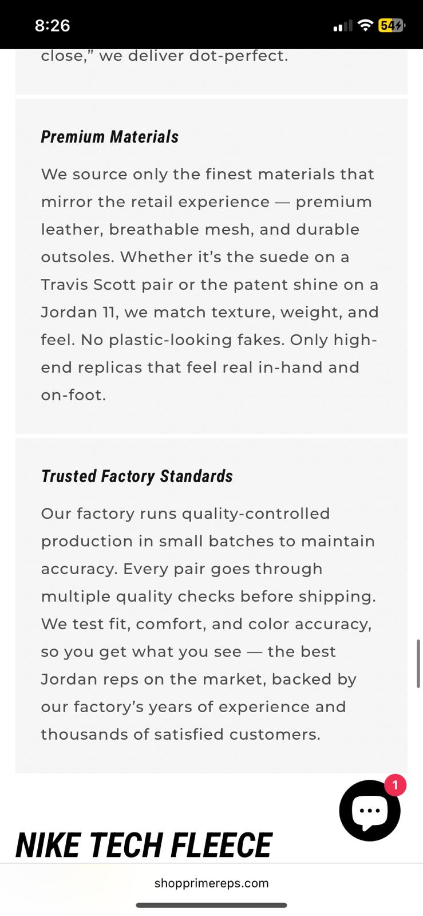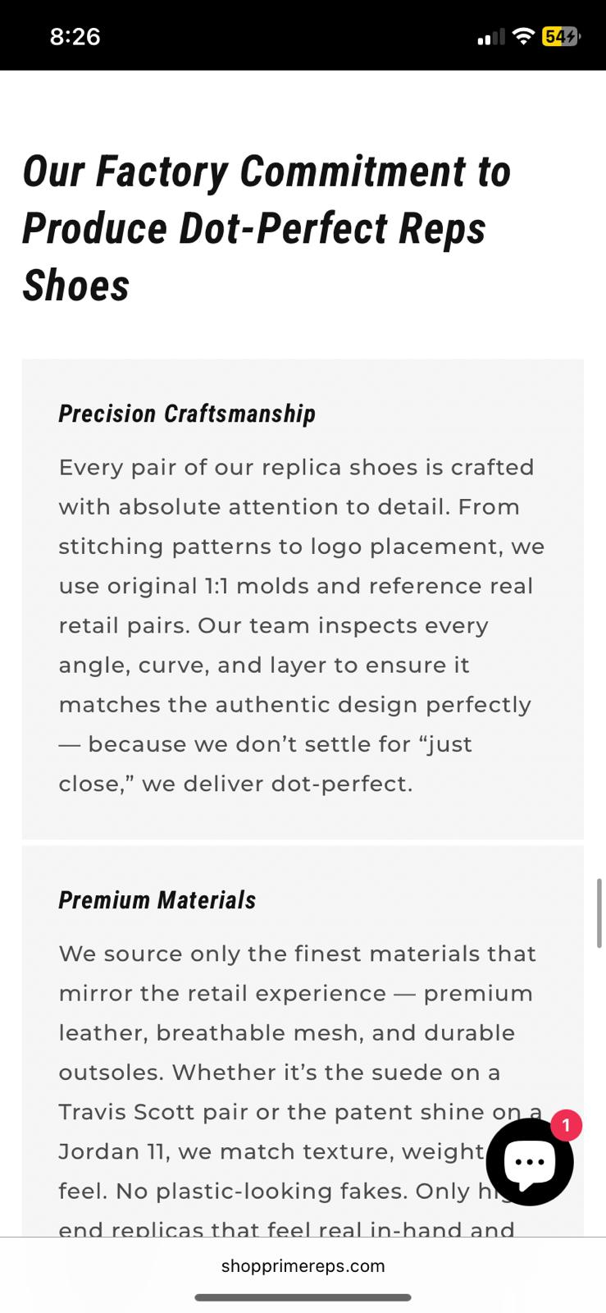  
4.and at the last end after these add support email🡪limitedrepsbusiness@gmail.com  
**Explore Product Page**  
I am giving you a json below of all the Product categories and their model names now what you have to do in this json where i mentioned product you have to find their image from google and download them and add them with model name and Price which will around 120$ for most products and 150$ for some good one also add discount and add images in such a way that i can edit them if i want in the code file and also some products only have Brand name so you have to just add them in that category and also at the end of in this page there should be small animation all the brand name slides to show attention and good vibe .

{

"categories": [

{

"category_name": "Shoes",

"subcategories": [

{

"subcategory_name": "Air Jordan",

"products": [

"Air Jordan 1 Low",

"Air Jordan 1 Mid",

"Air Jordan 1 High",

"Air Jordan 3",

"Air Jordan 4",

"Air Jordan 5",

"Air Jordan 6",

"Air Jordan 11",

"Air Jordan 12",

"Air Jordan 13",

"Air Jordan Legacy 312 Low"

]

},

{

"subcategory_name": "Luxury Brand",

"products": [

"Louis Vuitton",

"Gucci",

"Dior",

"Prada",

"HERMES",

"DOLCE & GABBANA",

"Valentino",

"Christian Louboutin",

"Givenchy",

"Burberry"

]

},

{

"subcategory_name": "Fashion Brands",

"products": [

"Alexander McQueen Women",

"Alexander McQueen Men",

"Versace Women",

"Versace Men",

"Armani",

"Lanven",

"Rick Ovens",

"Fear Of God",

"AMIRI",

"GGDB",

"Giuseppe Zanotti",

"Loro Piana",

"PHILLIPE PIEIN",

"Converse",

"VANS",

"Salomon",

"UUG",

"Hoka"

]

},

{

"subcategory_name": "Basketball Shoes",

"products": [

"Kobe",

"Kyrie",

"PG",

"GT CUT",

"Harden",

"Air More UPtempo",

"LeBorn",

"Anthony Edwards",

"KD",

"DevinBooker",

"Giannis Imortality"

]

},

{

"subcategory_name": "NIKE",

"products": [

"SB Dunck",

"Air Force 1",

"Sacai",

"Pegasas",

"Zoom Fly",

"Air More UTempo",

"TN",

"Air MAX",

"Air Max Plus",

"Zoom"

]

},

{

"subcategory_name": "Adidas",

"products": [

"Yeezy 350",

"Yeezy 500",

"Yeezy 700",

"Yeezy Slide",

"Ultra Boost",

"Samba",

"Forum",

"Gazelle",

"Responce",

"SuperStart",

"Handballs Spzl",

"Campus"

]

},

{

"subcategory_name": "Balanciaga",

"products": [

"Track Trainer",

"Speed Trainer",

"Runner",

"Triple S",

"Phantom 3XL",

"Track 2",

"Defender",

"Cargo",

"Stapler"

]

},

{

"subcategory_name": "New Balance",

"products": [

"NB 9060",

"NB 2002 R",

"NB 990",

"NB 991",

"NB 992",

"NB 997",

"NB 327",

"NB 530",

"NB 550"

]

}

]

},

{

"category_name": "Clothes",

"subcategories": [

{

"subcategory_name": "Luxury Brand",

"products": [

"Louis Vuitton",

"Gucci",

"Chanel",

"Prada",

"Dior",

"Fendi",

"DOLCE & GABBANA",

"Monceler",

"Berbery",

"Balancaiga",

"Vercase",

"BALMAIN Men",

"BALMAIN Women",

"Givenchy",

"Loewe",

"Celine",

"Miumiu",

"Arcteryx",

"Fear Of God"

]

},

{

"subcategory_name": "Fashion Brand",

"products": [

"Sp5der",

"Amiri",

"Ami Paris",

"Aape",

"ANTI SOCIAL SOCIAL CLUB",

"Air Jordan",

"Askyurself",

"Armani",

"Adidas",

"Acne Studios",

"ARC`TERYX",

"Alexender McQueen",

"Boss",

"Bape",

"Balmain"

]

},

{

"subcategory_name": "Down Jacket",

"products": [

"Many Brands",

"Prada Women",

"Prada Man",

"Prada",

"Fendi",

"Burberry",

"Moncler",

"Moncler Man",

"Moncler Women",

"Canada Goose Man",

"Canada Goose Women",

"Canada Goose",

"The North Face",

"Moose Kunckles Man",

"Nike Man",

"Nike Women",

"Adidas Man",

"Adidas Women"

]

},

{

"subcategory_name": "Baseball Jacket",

"products": [

"Many Brands",

"Louis Vuitton"

]

},

{

"subcategory_name": "Windbreaker",

"products": [

"Many Brands",

"Many Brands Man",

"Many Brands Women"

]

},

{

"subcategory_name": "T-Shirt",

"products": [

"Many Brands",

"Louis Vuitton",

"Gucci",

"Balangsaiga",

"Armani",

"Moschino",

"Nike Man",

"Nike Women",

"Adidas Man",

"Adidas Women",

"Off white"

]

},

{

"subcategory_name": "Polo Shirts",

"products": [

"Short Sleeve polo",

"Long Sleeve Polo",

"Many Brands Suit"

]

},

{

"subcategory_name": "Shirts",

"products": [

"Many Brands",

"Long Sleeve shirt",

"Louis Vuitton",

"DIOR",

"Versace"

]

},

{

"subcategory_name": "Long Sleeve",

"products": [

"Many Brands",

"Louis Vuitton",

"GUCCI",

"Armani",

"Burberry"

]

},

{

"subcategory_name": "Track Suit",

"products": [

"Many Brands",

"Foodball Jersey",

"NBA Jersey"

]

},

{

"subcategory_name": "Shorts",

"products": [

"Many Brands",

"Nike Man",

"Nike Women",

"Adidas Man",

"Adidas Women"

]

},

{

"subcategory_name": "Pants",

"products": [

"Many Brands",

"Jeans",

"Casual Pants",

"Louis Vuitton",

"Gucci",

"DIOR",

"Burberry",

"Balangsaiga",

"Armain",

"Nike Man",

"Nike Women",

"Adidas Man",

"Adidas Women"

]

},

{

"subcategory_name": "Hoodies/SweatShirt",

"products": [

"Many Brands",

"Seat Shirt",

"Nike Man",

"Nike Women",

"Adidas Man",

"Adidas Women"

]

},

{

"subcategory_name": "Sweater",

"products": [

"Many Brands",

"Louis Vuitton",

"GUCCI",

"Berbery",

"DIOR",

"Versace"

]

}

]

}

]

}

**Send Message Page**

make sure there’s a option to fill in all the details t like full address , name , etc , product information, size , specific product etc, and forward all that information to my WhatsApp or number and they can text me through there and remember my number and email must not visible to them when they add all their details with number and email make a script so can when the press send button every detail goes to my WhatsApp number and email .And they must have to add number email and address.  
WhatsApp🡪1+ 5106609281  
Email🡪limitedrepsinformation@gmail.com

Note🡪Donot add word replica and similar in the website just Reps and also Make it beautiful and attractive product images must be valid not random one and also you can add some animations by yourself to make it attractive and when user send info it must send to my whatsapp and email